SETTING UP THE APPLICATION ENVIRONMENT

Docker CLI Installation

|  |  |
| --- | --- |
| **DATE** | 12 November 2022 |
| **TEAM ID** | PNT2022TMID10872 |
| **PROJECT NAME** | Inventory Management System for Retailers |

**Docker CLI Installation:**

Command

>> start /w “” “Docker Desktop Installer.exe” install

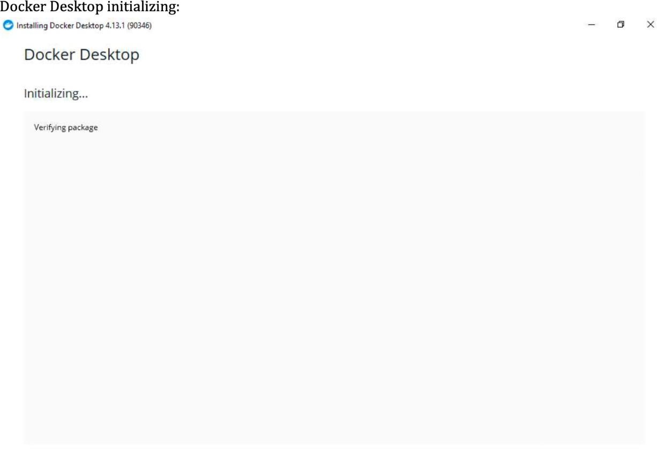

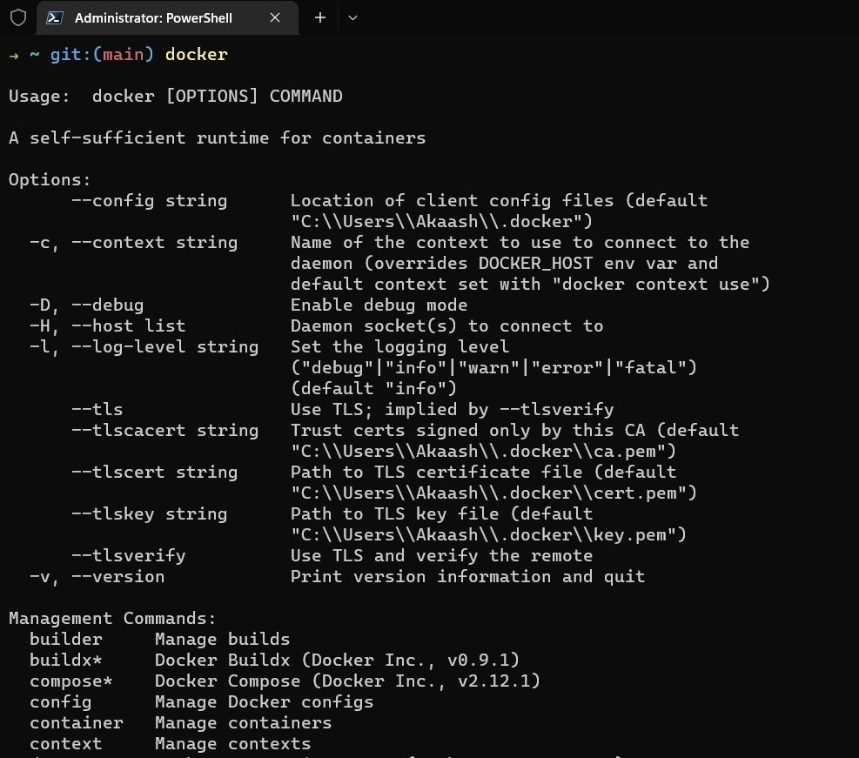**Docker CLI Installation :**

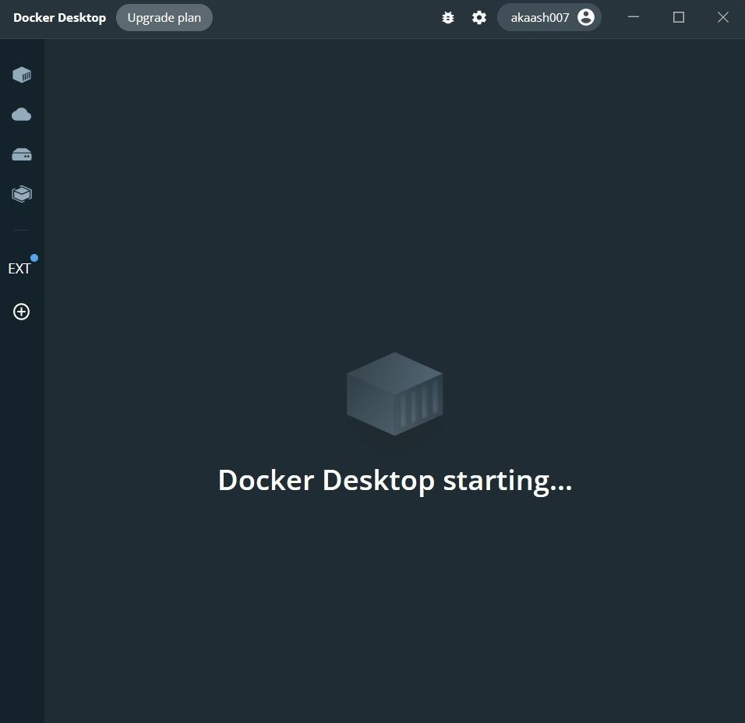**Docker Desktop:**